Auto Pac-Automatic Puffed making machine
অটোমেটিক মুড়ি ভাজার মেশিন
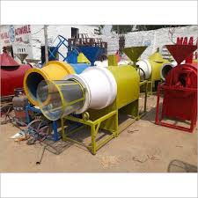  Muri-Puffed making machine | 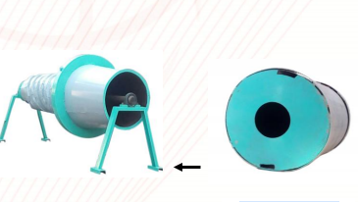  Roaster machine dryer machine
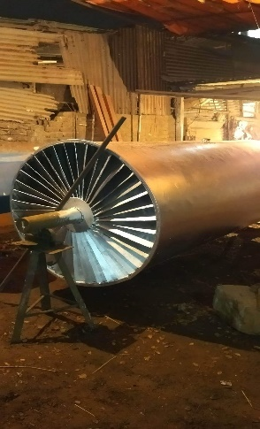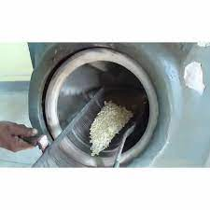  Dryer machine Roaster machine | 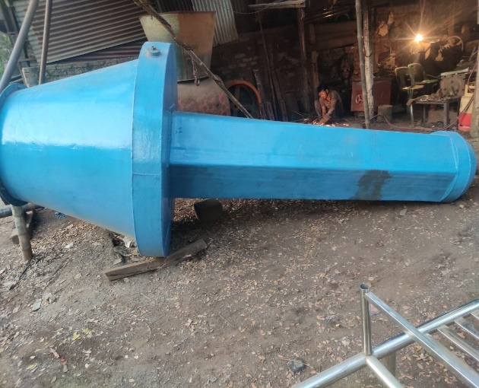  Roaster machine
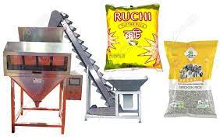  Weight sale packing and auto convayor machine | 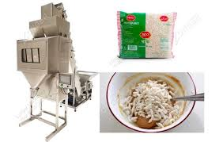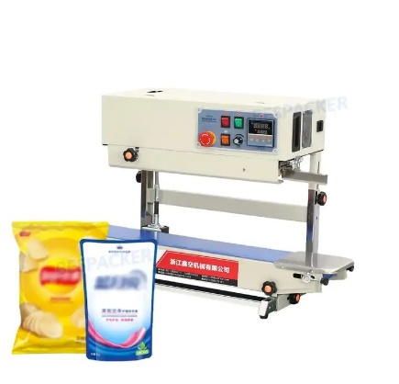  Muri weight sale packing machine and auto sealing machine
Auto Pac 128/3 kawran bazar Dhaka 1215 Bangladesh (near standard chartered bank north side)
Mobil:01631769707-01818496642, email: autopacbd@gmail.com web: www.autopacbd.com
1
Auto Pac-Automatic muri Baja machine
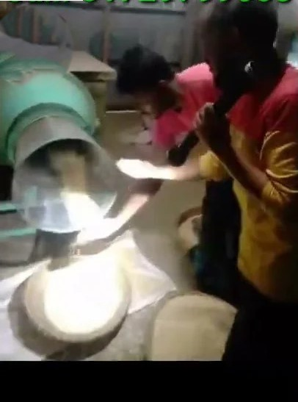
Auto Pac-automatic muri- puffed rice making machine
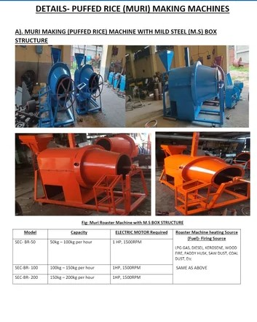
Auto Pac 128/3 kawran bazar Dhaka 1215 Bangladesh (near standard chartered bank north side)
Mobil:01631769707-01818496642, email: autopacbd@gmail.com web: www.autopacbd.com
2

